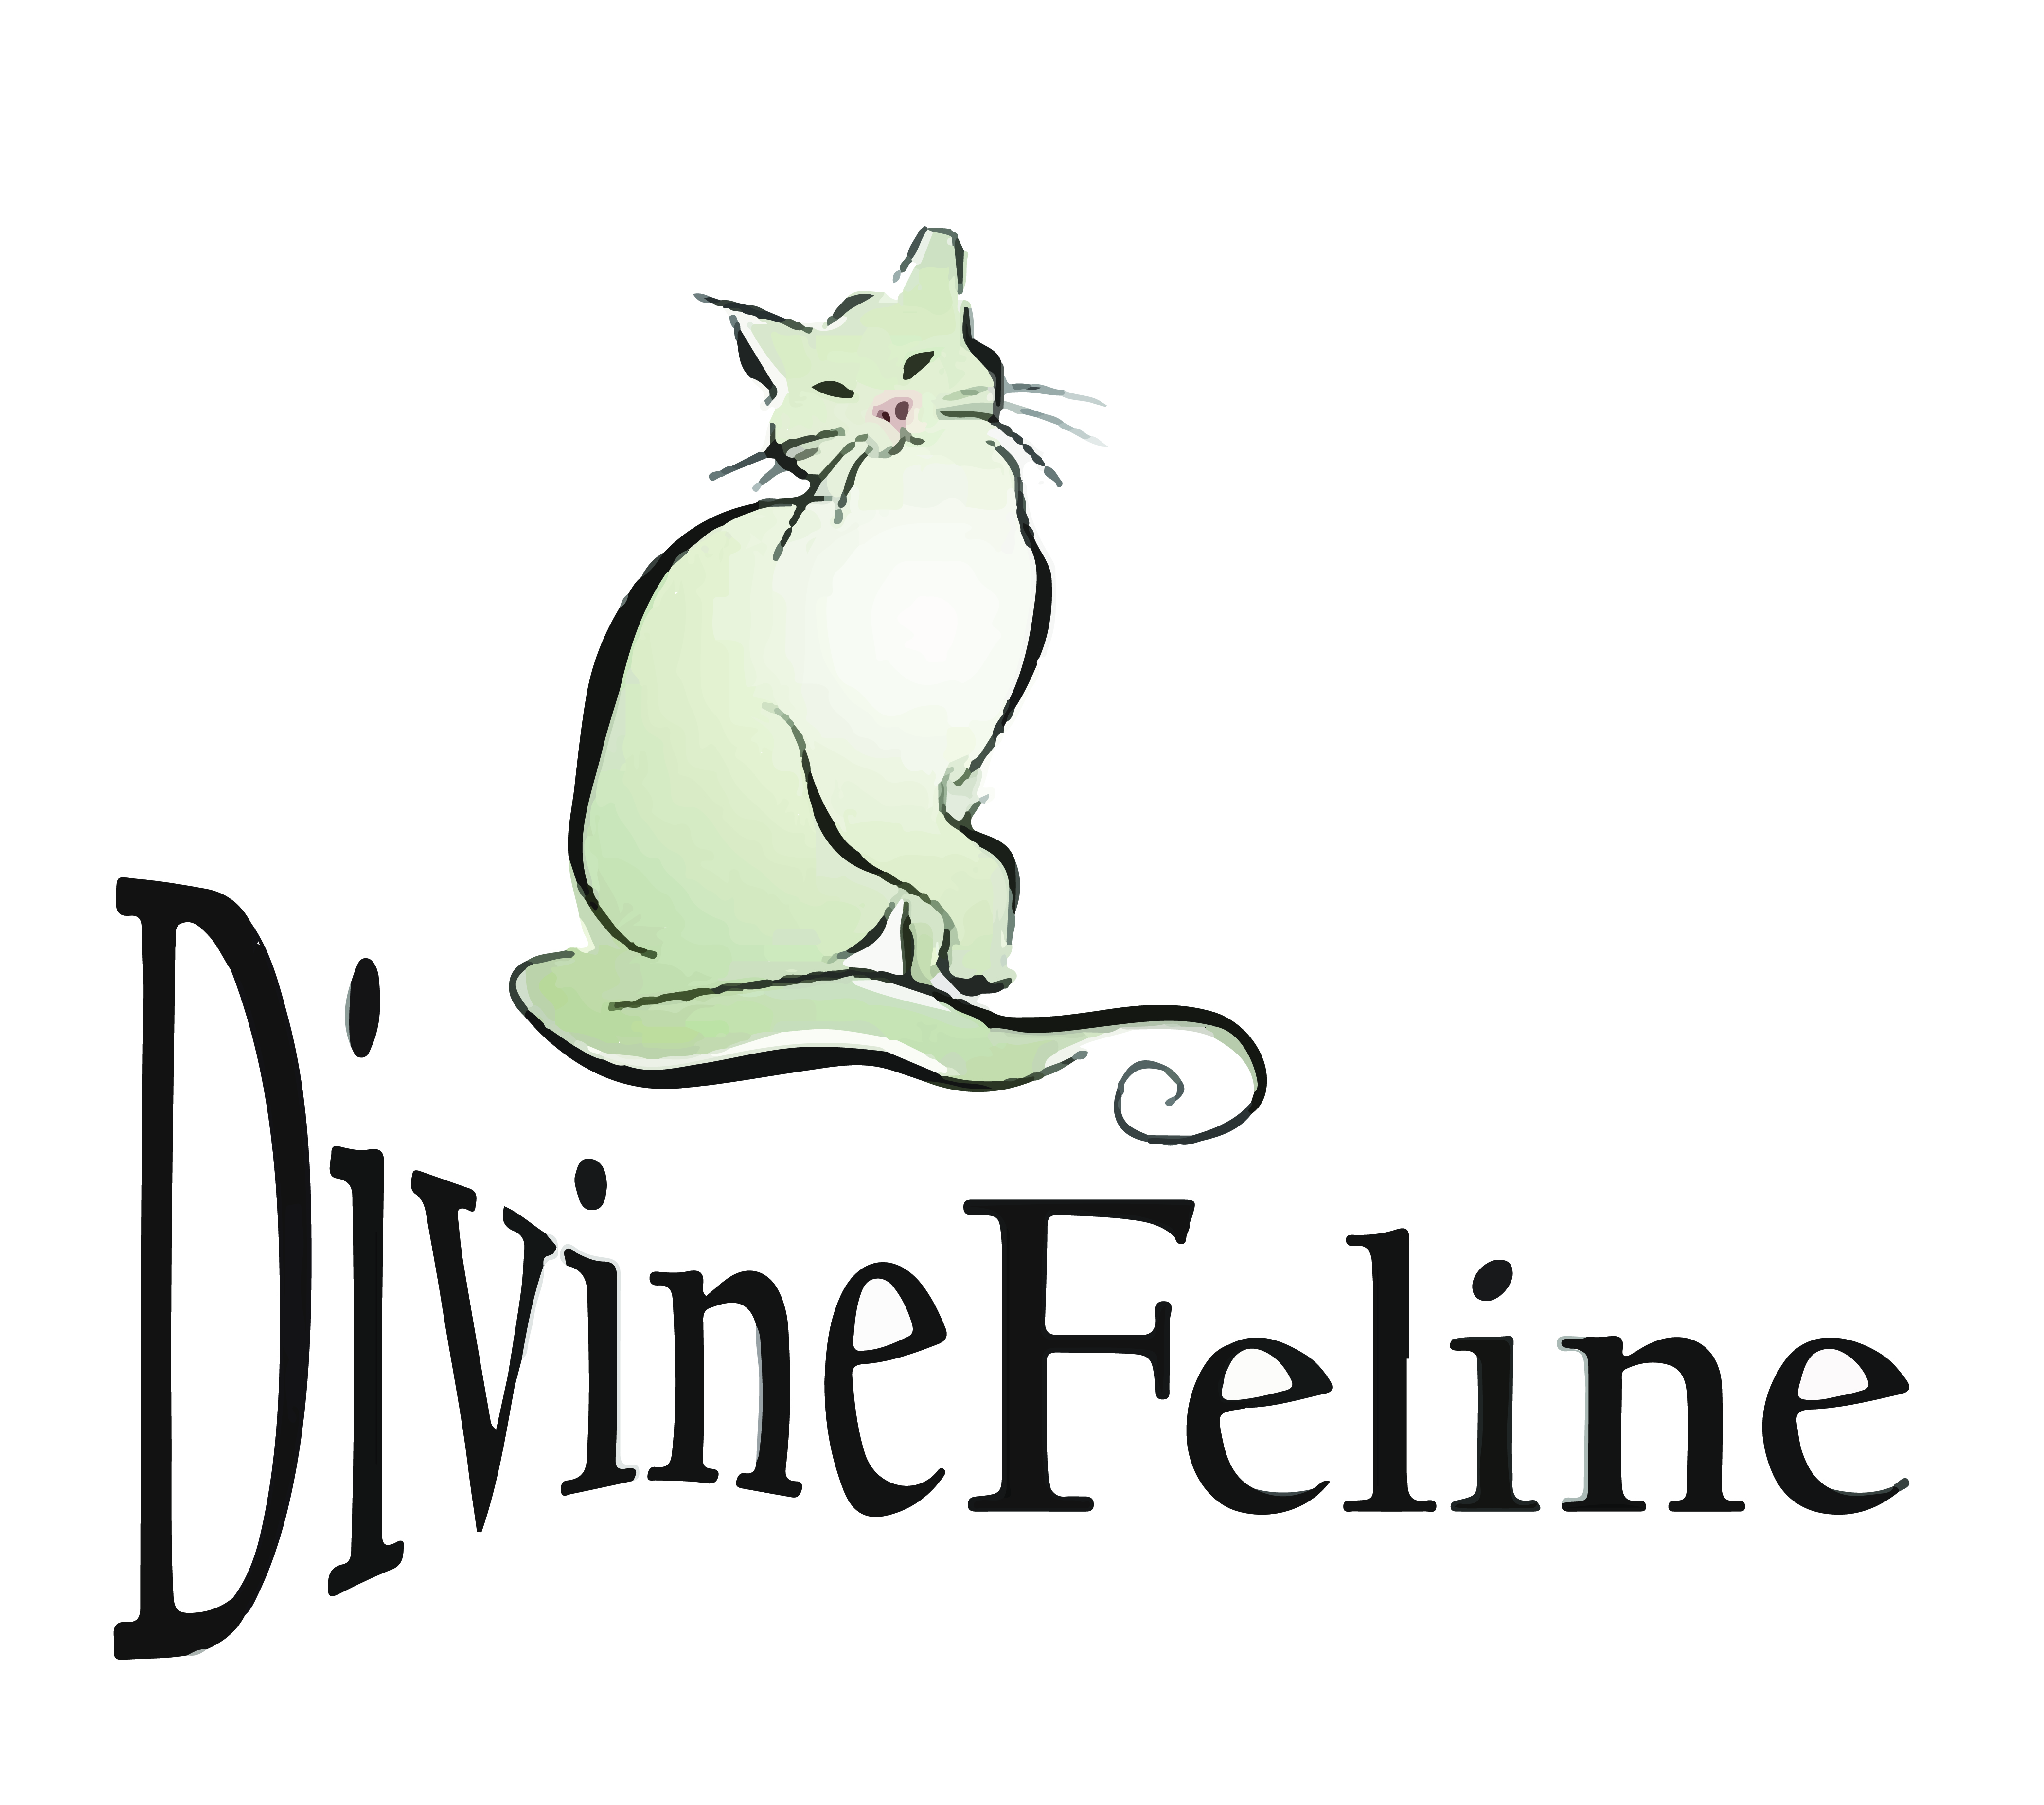

Divine Feline Volunteer Application

Welcome to Divine Feline, Inc., and thank you for your interest in volunteering. We are one of the leading spay and neuter organizations for community cats in the Denver metropolitan area. Our success in caring for more than 35,000 cats over the last decade is in large part due to the devotion of our volunteers.

Our volunteers help in a multitude of ways as the eyes, ears, and hands of our organization. Some volunteers directly help care for our felines within the medical spay and neuter clinic. Others are humane trappers who help provide essential care for many of our community cats.

Equally important are our tireless volunteers who help manage information in and out of the clinic providing critical direction so the public can care appropriately for the animals that need our help.

We have volunteers who educate our community at festivals and meetings. Others help us with our auctions and events by collecting donations from vendors, preparing and participating in our amazing fundraising events.

Some volunteers help weekly. Others help us more sporadically on an as-needed basis. Think about why you want to volunteer with Divine Feline, Inc., and how much time you can devote to supporting Divine Feline. Inside this packet you will find a volunteer application, a volunteer agreement, and general descriptions of the areas in which you can volunteer your time. Fill out these forms and bring them with you to the next volunteer orientation session held at Divine Feline. At this orientation, you will receive a copy of the more comprehensive volunteer manual. Volunteer orientation is held by the volunteer coordinator monthly at Divine Feline located at 2600 W. 2nd Avenue in Denver. Call 303-202-3516 or check the web site to confirm the date for the next orientation session.

Once you have completed the orientation and required forms, you will be able to sign up for available volunteer positions using our sign up system.

Thank you for your interest in Divine Feline and for making a real difference for the animals in our community. We look forward to working with you in the future!

DIVINE FELINE VOLUNTEER APPLICATION

DATE:_____________________

NAME:_____________________________________ AGE: ( if under 18years)______________

ADDRESS_________________________________CITY______________________ZIP_________

HOME PHONE #____________________________ CELL PHONE #_____________________

E-MAIL ADDRESS_______________________________________________________________

EMERGENCY CONTACT_____________________________ PHONE #______________________

HOW DID YOU FIND OUT ABOUT THE VOLUNTEER PROGRAM?__________________________

DO YOU HAVE DOGS/CATS AT HOME? _____YES _____NO

ARE THEY SPAYED OR NEUTERED? _____YES _____NO

DO YOU HAVE A VALID COLORADO DRIVER’S LICENSE? _____YES _____NO

DO YOU HAVE A CAR AND WOULD YOU BE WILLING TO DRIVE IT AS PART OF YOUR VOLUNTEER WORK? ____YES_____NO

IS THE CAR YOU WOULD BE DRIVING COVERED BY LIABILITY INSURANCE?

_____YES _____NO

HAVE YOU EVER BEEN CONVICTED OF A FELONY OFFENSE? _____YES _____NO

IF YES, PLEASE EXPLAIN: ______________________________________________________________________________

ARE YOU PRESENTLY EMPLOYED? _____YES _____NO _____ RETIRED _____ OTHER

DESCRIBE PREVIOUS VOLUNTEER EXPERIENCE________________________________________
______________________________________________________________________________
____________________________________________________________________________________________________________________________________________________________

SPECIAL SKILLS, CERTIFICATIONS, LICENSES, TRAINING, ______________________________________________________________________________
____________________________________________________________________________________________________________________________________________________________

DO YOU SPEAK SPANISH?___________________________________________________

ARE YOU AVAILABLE REGULARLY EACH WEEK? ____YES____NO

PLEASE INDICATE THE TIMES YOU WOULD BE AVAILABLE TO VOLUNTEER:

 | TUESDAY | WEDNESDAY | THURSDAY | FRIDAY | SATURDAY | Sunday or Monday
AM |  |  |  |  |  | Closed
PM | closed |  |  |  |  | Closed

AFTER READING THE VOLUNTEER MANUAL INCLUDING THE DECRIPTIONS OF THE VARIOUS VOLUNTEER PROGRAMS, PLEASE TELL US WHERE YOU ARE INTERESTED IN VOLUNTEERING:

______CLINIC ASSISTANT (Must have medical experience/plans or DVM permission)
______EDUCATION & OUTREACH
______FUNDRAISING/EVENT SUPPORT
______CLINIC ADMIN
______VOLUNTEER TNR SPECIALIST
______CLEAN UP CREW

I GIVE PERMISSION TO DIVINE FELINE TO VERIFY THE ABOVE INFORMATION AND VERIFY THAT I HAVE READ THE DIVINE FELINE VOLUNTEER MANUAL AND WILL COMPLY WITH THE EXPECTATIONS AS OUTLINED FOR DIVINE FELINE VOLUNTEERS.

SIGNATURE______________________________DATE________________________________

IT IS THE POLICY OF DIVINE FELINE, INC., TO PROVIDE EQUAL OPPORTUNITIES WITHOUT REGARD TO RACE, COLOR, RELIGION, NATIONAL ORIGIN, GENDER, SEXUAL PREFERENCE, AGE, OR DISABILITY.

Thank you for completing this application form
and for your interest in volunteering with us.

Emergency Contact Information Form
This information will be extremely important in the event of an accident or medical emergency.

Name:

______________________________

Primary Phone:

______________________________

Email Address:

______________________________

Address:

_____________________________________________________________

Primary Emergency Contact Name:

______________________________

Relationship:

______________________________

Primary Phone:

______________________________

Secondary Emergency Contact Name:

______________________________

Relationship:

______________________________

Primary Phone:

______________________________

Comments (include any special information you would want an emergency care provider to know):

________________________________________________________________________________________

Signature: Date:

_______________________________________________ ______________________

Volunteer Opportunities: Brief Description

CLINIC ASSISTANT (Must have medical experience/plans or DVM permission)
Provides support to certified veterinary technicians and veterinarians in providing quality, efficient medical care to community cats and family-owned cats.

Duties:
Introductory: No immediate animal contact.
- Clean surgical instruments following protocol from Appendix One.
- Assist with intake and discharge of surgical patients.
- Clean soiled traps and carriers.
- Dispense bedding, food and deworming solution.
- Assist with completion of surgical paperwork
- Help with laundry & environmental sanitation.

Advanced: Animal contact when confident under veterinarian supervision (optional).
- Deliver subcutaneous fluids to anesthetized patients.
- Deliver intramuscular injection of reversal agent to anesthetized patients.
- Safely remove endotracheal tubes after deflating cuffs from anesthetized patients.
- Tip left ear of anesthetized patients.
- Assess post-surgical responsiveness, breathing, cardiac rate on anesthetized patients.

EDUCATION & OUTREACH
Provides community education for audiences of all ages and background regarding the mission and activities of Divine Feline.

Duties:

- Present interesting, dynamic information about the organization in a professional and knowledgeable manner.
- Provide information about the services and programs of Divine Feline.
- Educate the public about feline overpopulation, the benefits of sterilization, and the Trap-Neuter-Return process.
- Endorse the humane treatment of animals.
- Staff booths at fairs and events.
- Professionally solicit volunteers and donations for the organization.
- Communicate with outreach coordinator regarding outreach content and approach as determined by audience.

FUNDRAISING/EVENT SUPPORT
Assist fundraising coordinator or executive director with event planning and implementation.

Duties:

- Solicit donated items for sales and auctions.
- Help arrange and price items for sales and auctions.
- Assist with thank you letters and tax documentation for solicited sale items.
- Assist with marketing of fundraising events.
- Help support caterers and performers during events.
- Help with guest entry and other service capacities during fundraisers.
- Help with set-up and breakdown of venues for fund-raisers.
- Communicate with fundraising coordinator regarding solicitation protocol.

CLINIC ADMIN
Provide client communication, and assist with clinic day check in/out. Data entry and answer phones, office space maintenance and record keeping assistance to Divine Feline staff members. Other duties as they may arise.

Duties:

- Data entry and recordkeeping.
- Assistance with phone calls.
- Assistance with making spay/neuter appointments.
- Assistance with special projects as needed.
- Updating databases.
- Cleaning office space.
- Assistance with computer networking or information technology.

TNR Specialist
Provides humane trapping assistance for large and small Trap-Neuter-Return projects.

Duties:

- Humanely trap cats for spay and neuter procedures.
- Safely and compassionately transport cats to and from The Feline Fix in a temperature controlled vehicle. Divine Feline does not provide the vehicle.
- Cats must have access to water at all times as well as food that is removed by 10 pm the night before surgery.
- Humanely return cats to the exact location from which they were trapped.

CLEAN UP CREW
Assists with cleaning up the clinic after clinic days. Laundry, mopping sweeping other cleaning needs as necessary.

Duties:

- Laundry
- Sweep and Mop
- Dust, and wipe down area
- Dishes

